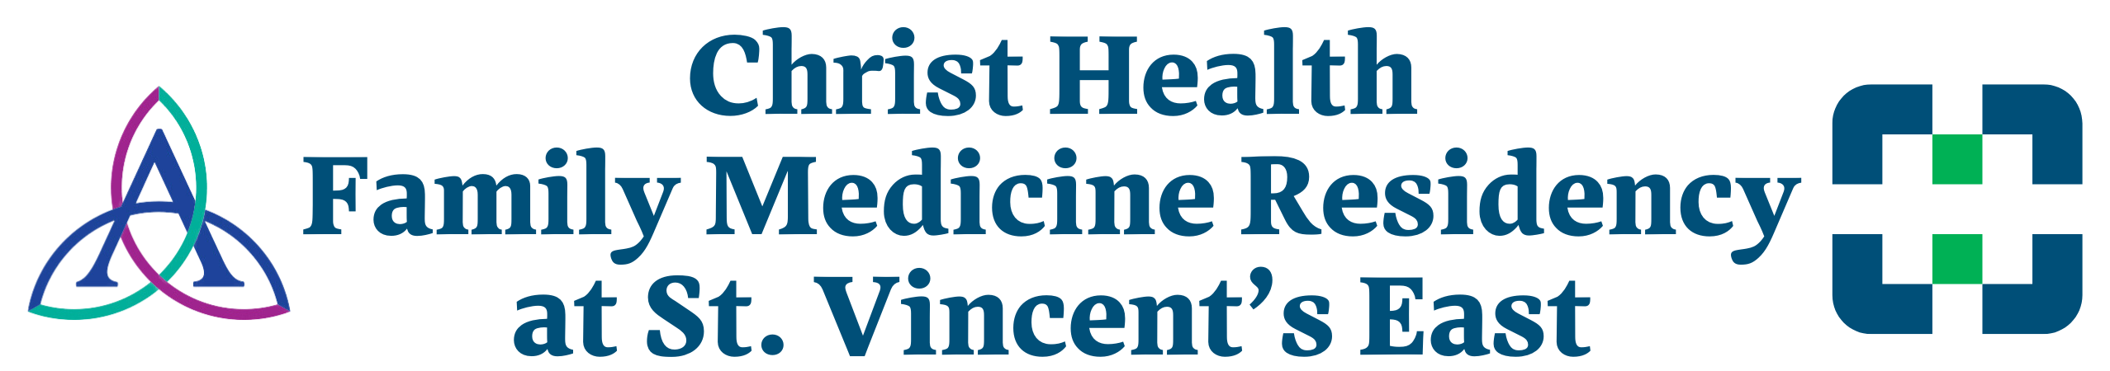

ANNUAL STIPEND
First Year | $58,400
Second Year | $61,000
Third Year | $63,000

LEAVE
- PTO =176 hours (January-December), excluding holidays
- Maternity/Paternity leave per AAFP Guidelines

INSURANCE
- HMO/HSA Health/Dental/Vision Insurance Plan Options
- Medical Malpractice Insurance: Occurrence $1,000,000/$3,000,000 plan
- Term Life Insurance
- Short-Term/Long-Term Disability Insurance

EDUCATIONAL/PROFESSIONAL
- Lab coat allowance: Interns receive 2 lab coats; PGY-2, PGY-3 receive one additional coat
- Tuition Reimbursement Plan
- Employee Behavioral Health Assistance Program
- Paid Certification for BLS, ACLS, NRP, ALSO, ATLS
- Paid membership for AAFP

